Wireshark Lab 5: Ethernet and ARP

Group Details:
Ho Seok Lee (1004112177)
Neehar Kantimahanti (1003872286)

Mark:

 | Question | Answer
1 | What is the 48-bit Ethernet address of your computer? | 38:f9:d3:ae:cc:74
Annotated Screenshot  (if needed) | 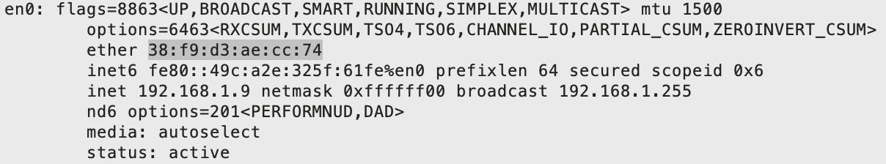
2 | What is the 48-bit destination address in the Ethernet frame?  What device has this as its  Ethernet address? | 00:06:25:da:af:73  The first-hop router in the route to the destination has this as its Ethernet address.
Annotated Screenshot  (if needed) | 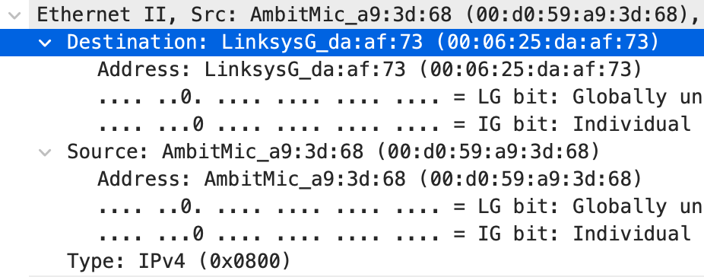
3 | Give the hexadecimal value for the two-byte Frame type field.  What upper layer protocol does this correspond to? | 0x0800  It corresponds to the Internet Protocol version 4 (IPv4).
Annotated Screenshot
(if needed)
4 | How many bytes from the very start of the Ethernet frame does the ASCII “G” in “GET” appear in the Ethernet frame? | The ASCII “G” appears 55 bytes from the very start of the frame.
Annotated Screenshot  (if needed) | 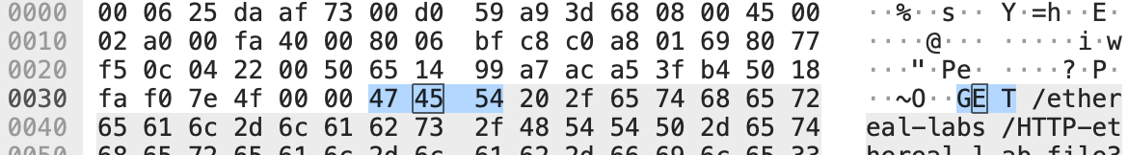
5 | What is the value of the Ethernet source address?  What device has this as its Ethernet address? | 00:06:25:da:af:73  The first-hop router in the route to the destination has this as its Ethernet address.
Annotated Screenshot  (if needed) | 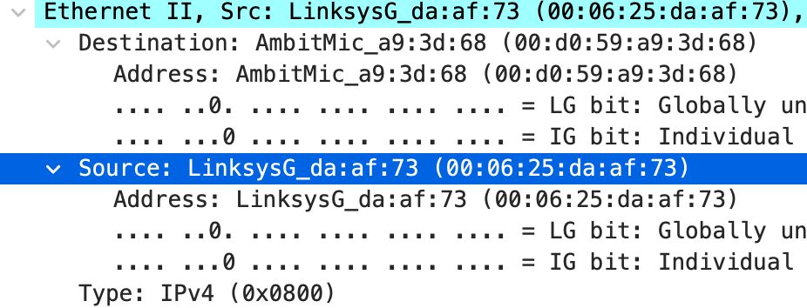
6 | What is the destination address in the Ethernet frame?  Is this the Ethernet address of your computer? | 00:d0:59:a9:3d:68  Ideally, yes. I used the pre-collected Wireshark traces from one of the authors, so it won’t match up with the Ethernet address of my computer.
Annotated Screenshot
(if needed)
7 | Give the hexadecimal value for the two-byte Frame type field.  What upper layer protocol does this correspond to? | 0x0800  It corresponds to the Internet Protocol version 4 (IPv4).
Annotated Screenshot
(if needed)
8 | How many bytes from the very start of the Ethernet frame does the ASCII “O” in “OK” (i.e., the HTTP response code) appear in the Ethernet frame? | The ASCII “O” appears 68 bytes from the very start of the frame.
Annotated Screenshot  (if needed) | 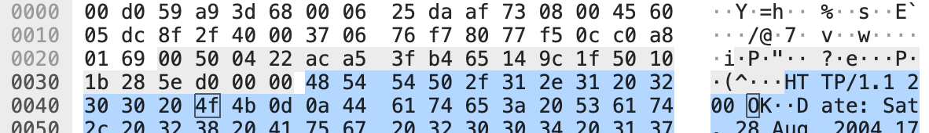
9 | Write down the contents of your computer’s ARP cache.  What is the meaning of each column value? | The first column represents domain name, second represents IP address, third represents MAC address, and fourth represents the physical network interface name.
Annotated Screenshot  (if needed) | 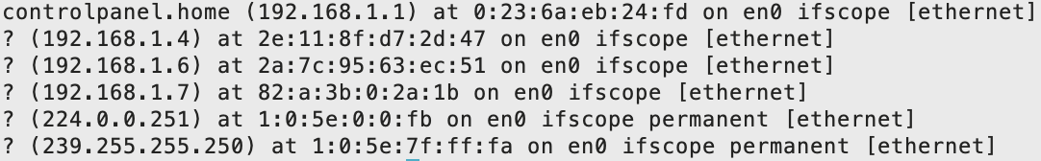
10 | What are the hexadecimal values for the source and destination addresses in the Ethernet frame containing the ARP request message? | Destination: ff:ff:ff:ff:ff:ff  Source: 00:d0:59:a9:3d:68
Annotated Screenshot  (if needed) | 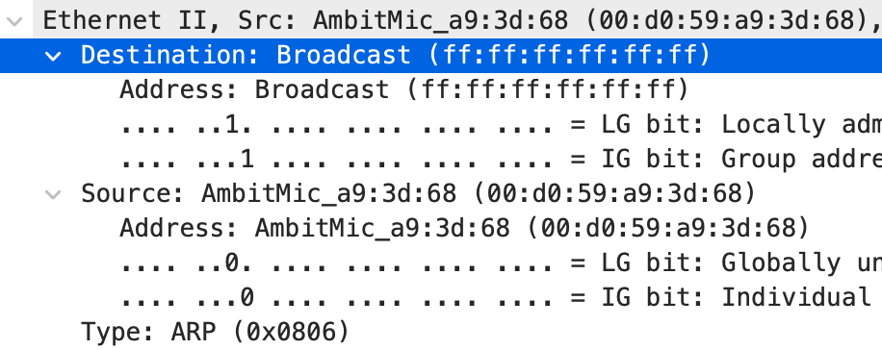
11 | Give the hexadecimal value for the two-byte Ethernet Frame type field.  What upper layer protocol does this correspond to? | 0x0806  It corresponds to the Address Resolution Protocol (ARP).
Annotated Screenshot
(if needed)
12.a | How many bytes from the very beginning of the Ethernet frame does the ARP opcode field begin? | The ARP opcode appears 21 bytes from the very start of the frame.
Annotated Screenshot  (if needed) | 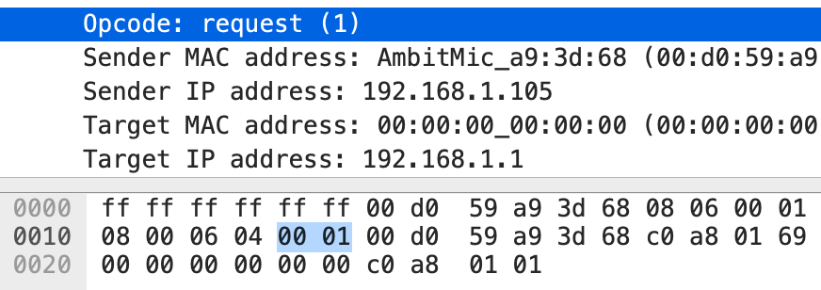
12.b | What is the value of the opcode field within the ARP-payload part of the  Ethernet frame in which an ARP request is made? | The value of the ARP opcode field is request (0x0001).
Annotated Screenshot
(if needed)
12.c | Does the ARP message contain the IP address of the sender? | Yes, the ARP message contains the IP address of the sender.
Annotated Screenshot
(if needed)
12.d | Where in the ARP request does the “question” appear – the Ethernet  address of the machine whose corresponding IP address is being queried? | The Ethernet address of the queried machine appears 33 bytes from the very start of the frame.
Annotated Screenshot  (if needed) | 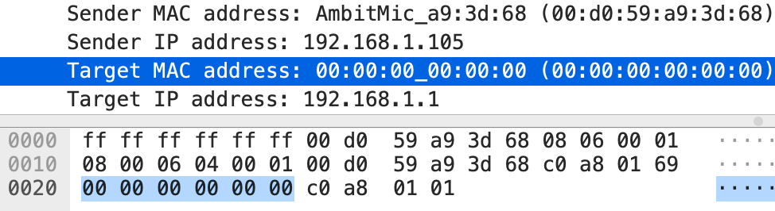
13.a | How many bytes from the very beginning of the Ethernet frame does the ARP opcode field begin? | The ARP opcode appears 21 bytes from the very start of the frame.
Annotated Screenshot  (if needed) | 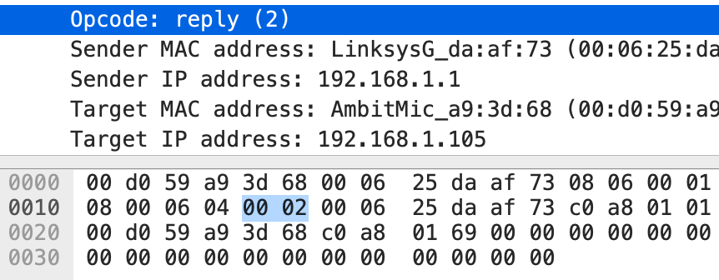
13.b | What is the value of the opcode field within the ARP-payload part of the Ethernet frame in which an ARP response is made? | The value of the ARP opcode field is reply (0x0002).
Annotated Screenshot
(if needed)
13.c | Where in the ARP message does the “answer” to the earlier ARP request appear – the IP address of the machine having the Ethernet address whose corresponding IP address is being queried? | The Ethernet address of the queried machine appears 33 bytes from the very start of the frame.
Annotated Screenshot  (if needed) | 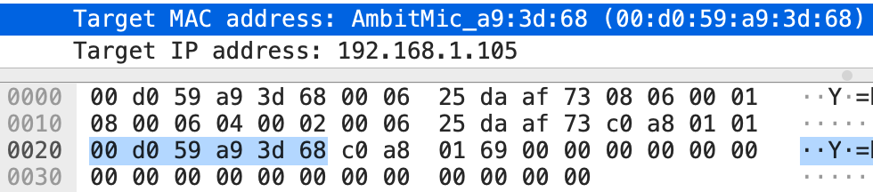
14 | What are the hexadecimal values for the source and destination addresses in the Ethernet frame containing the ARP reply message? | Destination: 00:d0:59:a9:3d:68  Source: 00:06:25:da:af:73
Annotated Screenshot  (if needed) | 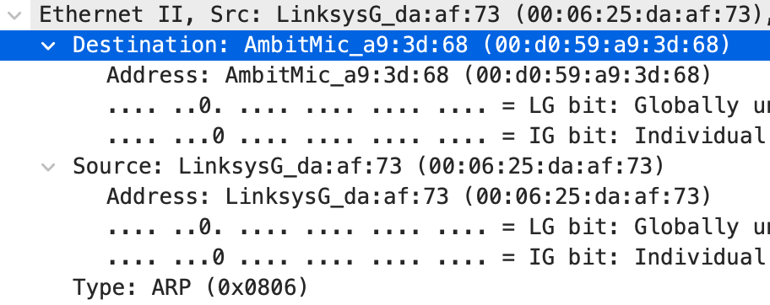
15 | Why is there no ARP reply (sent in response to the ARP request in packet 6) in the packet trace? | The ARP reply is only sent to the original sender of the ARP request, which is not the current machine. The current machine receives the ARP request regardless, since it is a broadcast.
Annotated Screenshot
(if needed)

